Business Action Plan

Week 1: Get to know your industry

The masterclass for week one addressed getting to know the tourism industry in Tasmania and your place as a tourism operator in it.

The following 10 questions are designed to delve into your business and discover how much you know about the industry and how much you already participate. For feedback, please complete and send to info@tict.com.au so one of our Industry Advisers can review.

Q1. Where do your customers come from?
Until Covid-19 restrictions hit, where were your customers coming from. ie. what are the various countries of origin and break this down by percentage of total visitors to your business.

 | Country | % of overall visitors to your business
1 | Australia
2
3
4
5
6
7
8
9
10
 | TOTAL | 100%

 | State | % of overall visitors to your business
1 | Tasmania
2 | Victoria
3 | New South Wales
4 | ACT
5 | Queensland
6 | Northern Territory
7 | Western Australia
8 | South Australia
 | TOTAL | 100%

Q2. Now let’s dig deeper into the people who are coming to your business.

Write down all the details you know including items such as:
- Buyer behaviour – how and when are they booking
- Preference – average length of stay, type of booking
- Repeat or new customer
- Why they are coming to you – for business, leisure? For adventure, simply to sleep, to learn etc.
- What else are they doing when they travel – visiting national parks, eating out, tasting wine, short/long walks, cruises, historic sites etc.

Q3. List the organisations and people that operate around your business location.

Local Tourism Association _____________________________________________
Regional Tourism Organisation _________________________________________
Local council tourism representative ____________________________________
Nearest visitor centre/s_______________________________________________
Other _____________________________________________________________

Q4. Which local industry colleagues do you partner with?

 | Business Name | Relationship
1 | Eg. XYZ hotel | Package accomm/tour
2 | Eg. ABC group | Marketing campaign
3
4
5
6
7
8
9
10
 | TOTAL | 100%

Q5. How will you tap into the newest “Make yourself at Home” campaign to target Tasmanian travellers?

Q6. What professional development programs do you participate in to ensure you and your business are the highest quality? Tick all that apply.

Tourism Accreditation
Advanced modules: Bike friendly, rainbow, export, covid clean
Tourism Awards
TICT Tourism Conference
Your RTO events
Tourism Incubator
ATEC membership and/or events
Business Events Tasmania
Events Tasmania
Tourism Tasmania events
TICT newsletter - Snapshots
Tourism Tasmania newsletter – Tourism Talk
Other ______________________________
Other ______________________________

Q7. List the ways that you participate in the tourism industry.
Eg. Attend tourism events, work collaboratively with other tourism operators, enter awards, undertake accreditation, membership of tourism organisations.

Q8. Are you listed on ATDW and update your listing regularly?

Provide your ID number here: ____________________________________
If you aren’t sure, you can find it here: https://atdw.com.au/our-listings/

It looks like this: 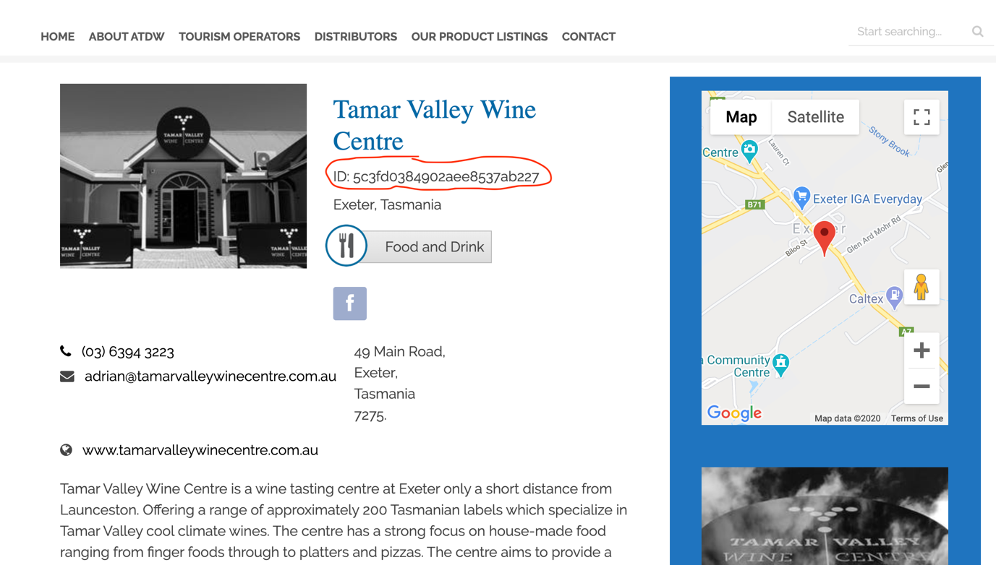

Q9. Are you listed with any OTA’s, wholesalers or ITO’s?
List them here:

Q10. What are the organisations/structures/concepts that David mentioned in his video that you would like to learn more about?

Email your completed copy to info@tict.com.au for one of our helpful advisers to review.

